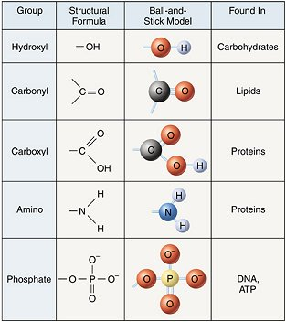
Basic Biochemistry – BIOL 12U
1. The Importance of Carbon
- Highly important element when teaching biochemistry
- Has 4 valence electrons, therefore can make up to 4 bonds
- Bonding capacity
- Various elements including H, O, S, and P can bond to carbon to form functional groups
- There are many functional groups found in biological molecules
- Using a periodic table to understand valance electrons

2. Anabolic and Catabolic Reactions
Anabolic reactions: produce large molecules from smaller subunits
- They include condensation reactions, where water is removed
Catabolic reactions: break macromolecules down into their individual subunits
- They include hydrolysis reactions, where water is needed

3. Biological Macromolecules: Carbohydrates
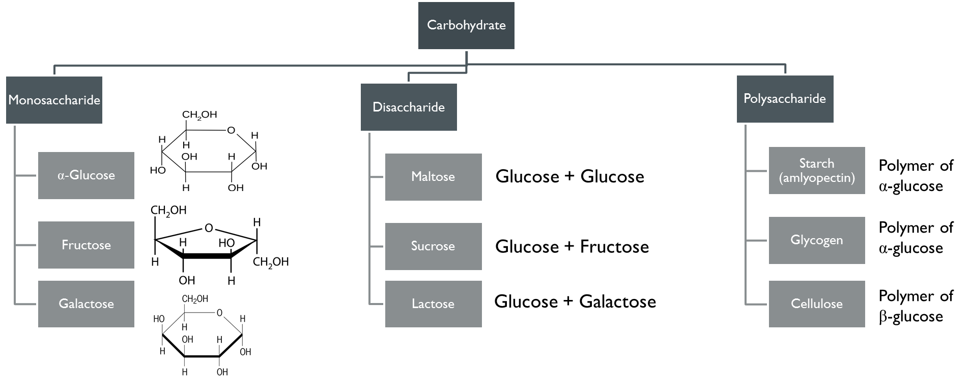
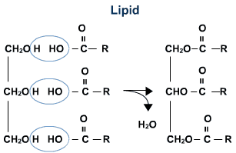
3. Biological Macromolecules: Lipids
- Hydrophobic molecules (non-polar) composed of C, H, and O
- Most common energy storing molecules
- Most common fats in plants and animals are triglycerides (3 fatty acids + glycerol)
- Saturated fatty acids: All single bonds between C atoms, max amount of H’s
- Unsaturated fatty acids: 1 or more double bonds between C atoms, fewer than max amount of H’s
- Phospholipids: Molecule that consists of 2 fatty acid tails + glycerol + phosphate group
- Make up the cell membrane

3. Biological Macromolecules: Proteins
- Most diverse molecules in living organisms
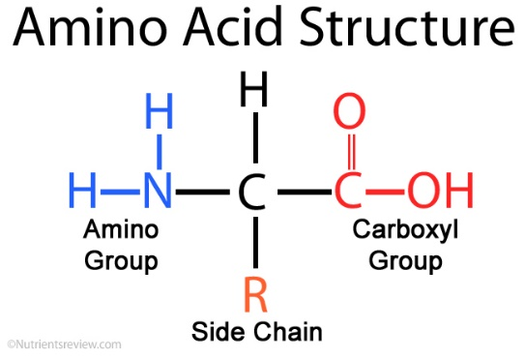
- Cells contain thousands of different proteins with various functions
  - Enzymes: Biological catalysts, speeding up chemical reactions
  - Immunoglobulins: Protect animals from foreign microbes
  - Hemoglobin: Carry oxygen throughout mammals
  - Keratin: Tough structural protein found in hair and fingernails
- Polymers of amino acids
  - Held together by peptide bonds
  - 20 different R groups in living organisms
  - 8 amino acids are considered essential

3. Biological Macromolecules: Nucleic Acids
- Store hereditary information of organisms
- DNA: (Double stranded) The digital code that stores the instructions for creating an organism
- RNA: (Single stranded) Reads the information in DNA and transports it to the protein-building apparatus of the cell
- Both are polymers of nucleotides
  - Nitrogenous base, pentose sugar, phosphate group
  - Phosphodiester bonds

4. STSE
Real world applications of protein enzymes
- Natural enzymes are used in many food production processes to speed up chemical reactions,
- Examples:
  - Rennet, a natural enzyme mixture from the stomach of calves, used in cheese making. Contains a protease enzyme that coagulates milk, causing it to separate into solids (curds) and liquids (whey
  - Enzymes produced by yeast have been used to ferment grape juice in order to make wine.
- Scientists are designing and producing synthetic enzymes that will be more efficient catalysts and allow new technological applications in medicine and industry.
  - Enzymes produced through biotechnology are identical to those found in nature.
  - Genetically modified microorganisms would not survive in nature.

