Population Dynamics Grade 12
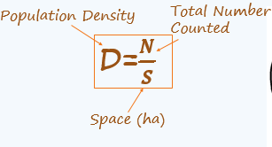
Populations – Size and Density
HIPPO
Habitat Loss
Invasive Species
Pollution
Population Growth
Over Harvest

Population Density: the number of individuals of the same species that occur per unit area or volume
Example: Find the population density of 210 black bears living in a 600 hectare region of Algonquin Park

Population Dispersion

Clumped Uniform Random
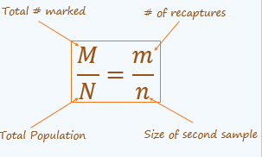
Sampling Techniques
- Quadrat Method- Most effective for stationary species such as the population of different tree species in a forest
- Mark-Recapture Method-A sample of organisms are captured, marked, and released
  - Population size and density can be calculated by comparing the proportion of marked and unmarked organisms in a given area
Mark-Recapture Sampling
Example
Scientists are interested in the population of wood ducks in a local wetland. Initially, 80 ducks were captured and marked. Two weeks later, 110 ducks were captured. Of the ducks recaptured, 12 were marked. Estimate the total size of the wood duck population in the area.
Calculations:

Assumptions made:
- Every organism has an equal opportunity of being captured

- Between sampling periods, the proportion of marked to unmarked animals remains constant
- The population size does not increase or decrease during the sampling study

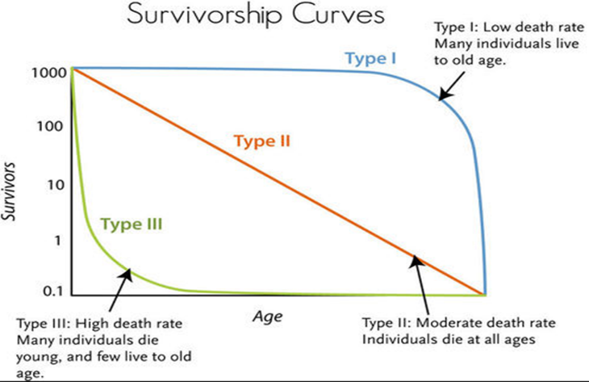
Carrying Capacity of an Ecosystem
- The maximum number of organisms that can be sustained by available resources over a limited period of time
- Carrying capacity is dynamic and is determined by the environment in which a population lives

Population Growth Models
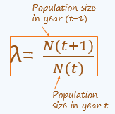
Geometric Growth Rate (λ)
- For many species, births are restricted to a particular time of year called the breeding season
- Deaths can occur at any time
- A pattern of population growth where organisms reproduce at fixed intervals at a constant rate
Exponential Growth Rate
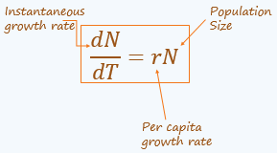
- Certain species, (bacteria for example) are able to reproduce continuously at a fixed rate in a fixed time interval
- Unlike geometric growth, the chosen time interval is not restricted to a particular reproductive cycle
- Example: A population of 2500 yeast cells in a culture grows exponentially. If the per capita growth rate, r is 0.030 per hour what is the initial instantaneous growth rate of the population?
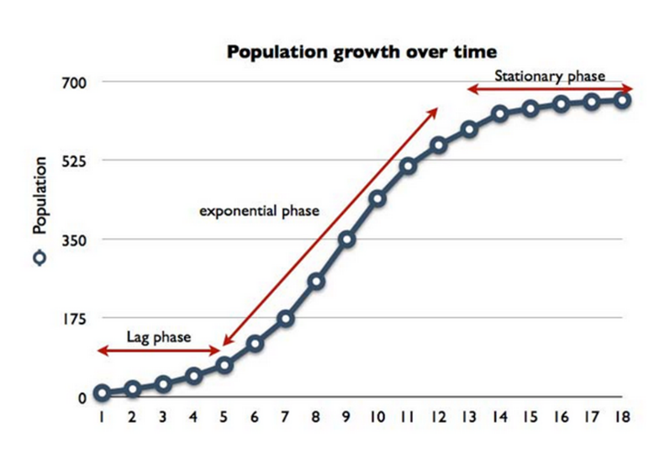
Logistic Growth Curve
- Lag phase-small population
- Log phase-rapid growth
  - Environmental resistance
- Stationary phase-dynamic equilibrium

